Dancer’s Name: ___________________________________Name of Parent filling out form: _____________________________________

Email Address: ____________________________________________________________________________________________________

Size Chart: Chassé Sport Uniform Tops
Size | Chest | Waist  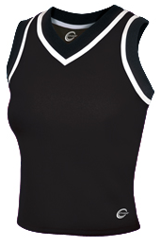$18.95  Top Size: ____________________
YXS (Youth Extra Small) | 24" | 22"
YS (Youth Small) | 26" | 24"
YM (Youth Medium) | 28" | 27"
YL (Youth Large) | 30" | 30"
XS (Adult Extra Small) | 32" | 28"
S (Adult Small) | 34" | 30"
M (Adult Medium) | 36" | 32"
L (Adult Large) | 38" | 34"
XL (Adult Extra Large) | 40" | 36"
XXL (Adult Extra Extra Large) | 43" | 40"
Chest: Measure around fullest part of the chest.
Waist: Measure around the waist (don't measure over clothes).

Size Chart: Chassé Body Suits
Size | Bust  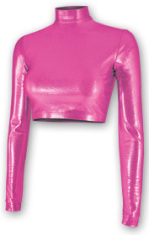 $19.75  Body Suit Size: ________________
YXS (Youth Extra Small) | 22"
YS (Youth Small) | 24"
YM (Youth Medium) | 26"
YL (Youth Large) | 28"
S (Adult Small) | 34"
M (Adult Medium) | 36"
L (Adult Large) | 38"
XL (Adult Extra Large) | 42"
XXL (Adult Extra Extra Large) | 46"
Chest/Bust: Measure around fullest part of the chest.

Size Chart: Chassé Uniform Skirts
Size | Waist | Hips | Length  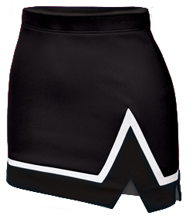$18.95  Skirt Size: ____________________
Youth Extra Small | 20" | 28" | 9"
Youth Small | 22" | 29" | 10"
Youth Medium | 24" | 32" | 11"
Youth Large | 26" | 34" | 12"
Adult Extra Small | 26" | 36" | 13"
Adult Small | 28" | 38" | 13 1/2"
Adult Medium | 30" | 41" | 14"
Adult Large | 33" | 44" | 15"
Adult Extra Large | 36" | 49" | 16"
Adult Extra Extra Large | 39" | 52" | 17"
Waist: Measure around the waist (don't measure over clothes).
Length: Measures the top of the skirt to bottom.
Hips: Measure around body at fullest part.
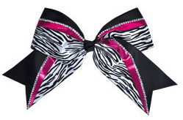$5.95

Choose a shoe size. Place an “x” in the appropriate box.
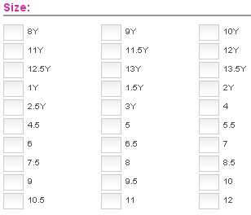
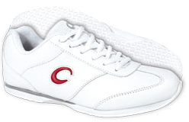
$16.95
The shoes run at least 1 full size too small. Please order accordingly.

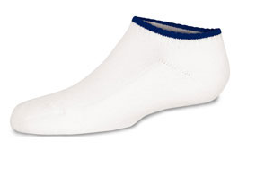
$2.95
Adult size only

Total Due: $_____

Total Due: $83.50

New Dancers: Returning Dancers:

Dancers will be REQUIRED to purchase solid black leggings that come down to the ankle. This is not included in the order and must be purchased on your own. Any brand will work.
If you are interested in purchasing a used uniform item, place a check next to the item you need. If the item is available in your dancer’s size, you will be notified via email. Please pay the full regular price, and you will be refunded the difference if a used item is available.
____ Used top ($10)
____Used Crop Top Body Suit ($11)
____Used skirt ($10)
____Used shoes ($7)

